# Sample Notification Templates

### Creating the Deep Link

Inside the $$altID$$ url link it contains the parameter $$acarecordurl$$. When this is pasted into the Content window it sometimes loses the variable. After it is pasted it should show up as the below without a backslash at the end as shown below.

https://$$acarecordurl$$

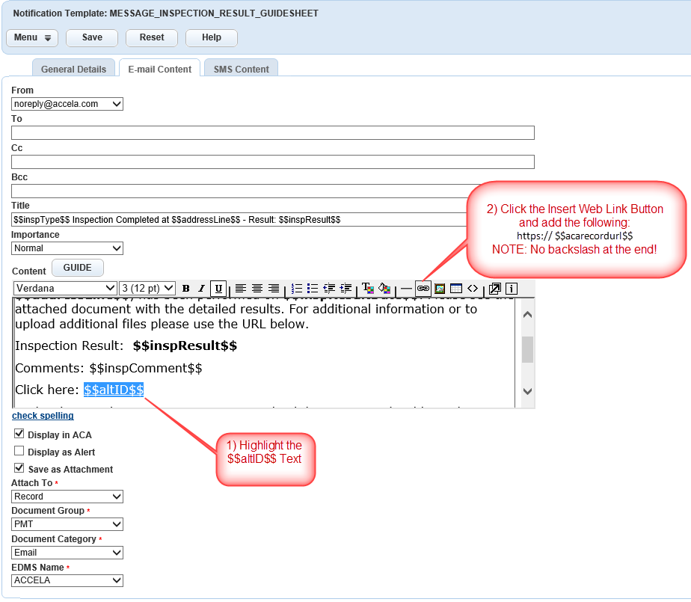

### MESSAGE_INSPECTION_RESULT_GUIDESHEET

Email Content Tab

**Title**: $$inspType$$ Inspection Completed at $$addressLine$$ - Result: $$inspResult$$

**Content:**

Dear $$ApplicantFirstName$$ $$ApplicantLastName$$,

An **$$inspType$$** inspection of **$$recordTypeAlias$$** Permit at the location **$$addressLine$$**, has been performed on **$$inspResultDate$$**. Please see the attached document with the detailed results. For additional information or to upload additional files please use the URL below.

Inspection Result:  **$$inspResult$$**

Comments: $$inspComment$$

Click here: [$$altID$$](https://$$acarecordurl$$)

Under the Attachments section you can upload documents with Additional Information that details the submittal requirements.

Thank you.

Building Department

### MESSAGE_PERMIT_ISSUED_REPORT

Email Content Tab

**Title**: $$recordTypeAlias$$ Permit Issued - $$altId$$

**Content**:

Dear $$ApplicantFirstName$$ $$ApplicantLastName$$,

Your **$$recordTypeAlias$$** Permit: **$$capName$$** at the location: **$$addressLine$$**, has been issued. Please see the attached document. For additional information or to upload additional files please use the URL below.

Additional Comments: $$wfComment$$

Click here: [$$altID$$](https://$$acarecordurl$$)

Under the Attachments section you can upload documents with Additional Information that details the submittal requirements.

Thank you.

Building Department

### MESSAGE_LICENSE_ISSUED_REPORT_DOCS

Email Content Tab

**Title**: $$recordTypeAlias$$ Issued - $$altId$$

**Content**:

Dear $$ApplicantFirstName$$ $$ApplicantLastName$$,

Your **$$recordTypeAlias$$** : **$$capName$$** at the location: **$$addressLine$$**, has been issued. Please see the attached document. For additional information or to upload additional files please use the URL below.

Additional Comments: $$wfComment$$

Click here: [$$altID$$](https://$$acarecordurl$$/)

Documents List:

$$acaDocDownloadUrlList$$

Under the Attachments section you can upload documents with Additional Information that details the submittal requirements.

Thank you.

City of Metropolis